|  |  |
| --- | --- |
|  | **2013** |
|  | ArbitraryY  Nick Squires |

|  |
| --- |
| **[PlTN] System Description Document (SDD)** |
| Requirements, Software/Hardware Architectures, Software/Hardware Maintenance, Installation, Operation Instructions |

Contents

System Requirements 2

Hardware 3

Architecture 3

System Schematic 3

Hardware Listing 3

Platoon Hardware System 4

Hardware Components Overview 4

Raspberry Pi 4

LED Driver Board 5

Arduino and Protoshield 6

Range Sensor 7

LCD Screen 8

System Assembly 9

Platoon Hardware Assembly 9

Software 15

Development Environment 15

Architecture Overview 15

Maintenance 16

User Guide 17

Software Upgrades 17

pltnUpdate.py 17

System Maintenance 17

Remote Connections 17

# System Requirements

Controllers will be built for each painting. The controllers need to function in the following 3 ways:

1. Playing the paintings: Controllers must accept MIDI/OSC commands via a WiFi network and translate those messages into commands that will activate the LEDs
2. Range Sensor Activation: Controllers must have a range sensor attached that will activate the LEDs based on predefined distances a user stands from each painting. There will be a predefined color scheme associated with each range
3. Web Application: Controllers must run a webserver and a web application that will allow a user that is connected to the same WiFi network, to activate and manually modify the color schemes using any device with a web browser. This will be useful once the paintings are sold to allow their user to modify colors as they please

# Hardware

## Architecture

### System Schematic

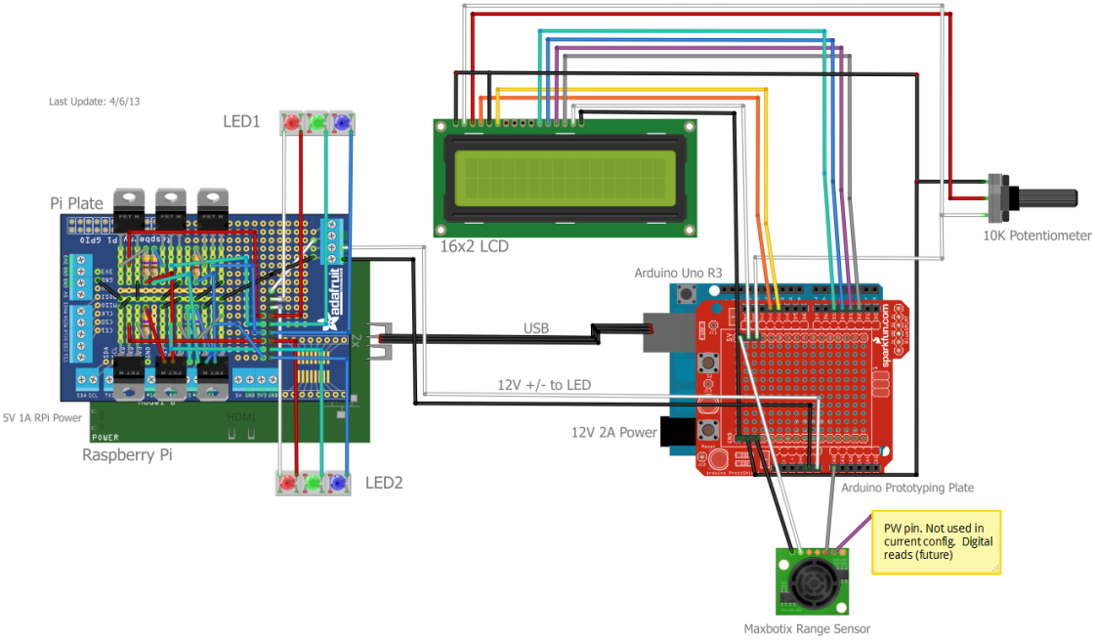

### Hardware Listing

#### Microcontrollers

* 1 x Raspberry Pi Model B
* 1 x Arduino Uno R3

#### LED Driver Board

* 6 x TIP 120 Transistor
* 6 x 470 Resistor
* 1 x Adafruit Pi Plate

#### Peripherals

* 1 x Edimax USB 802.11n/g/b WiFi Dongle
* 1 x 4GB SDHC Card Class 4 (already attached to RPi)
* 1 x 10K Potentiometer
* 1 x Arduino Protoplate
* 1 x Maxbotix LV-EZ1 Range Sensor
* 1 x 16x2 LCD Display
* 2 x LED Strips
* 1 x 12V, 2A Power Supply (Arduino)
* 1 x 5.25V, 1A Power Supply (Raspberry Pi), Micro USB-B input

# Platoon Hardware System

The following is an overview of each hardware components and their associated assembly instructions

## Hardware Components Overview

The Platoon hardware system consists of the following components

* 1 x Raspberry Pi Model B
* 1 x USB WiFi Dongle (already attached to RPi)
* 1 x 4GB SD Card (already attached to RPi)
* 1 x LED Driver Board
* 1 X Arduino Uno R3
* 1 x Arduino Protoboard (already attached to Arduino)
* 1 x 2’ USB-A to USB-B Cable
* 2 x 12V/GND wire (one black, one white)

### Raspberry Pi

The Raspberry Pi is the brain of the system. It is running the Raspbian Wheezy Linux Operating System and provides the following system functionality:

1. Webserver - Will host web based Host web applications
2. OSC Server - Accept OSC messages from Ableton (and any other OSC client) to change LED colors
3. Remote Access - SSH terminal access. Allows for remote software updates to RPi and Arduino
4. WiFi - WEP/WPA/WPA2 Network access
5. LED Controls - Software PWM to control brightness of LEDs. Change colors via webserver, OSC, or range sensor (sent over serial via Firmata from Arduino)

Below is an overview of the Raspberry Pi components you will be interested in.

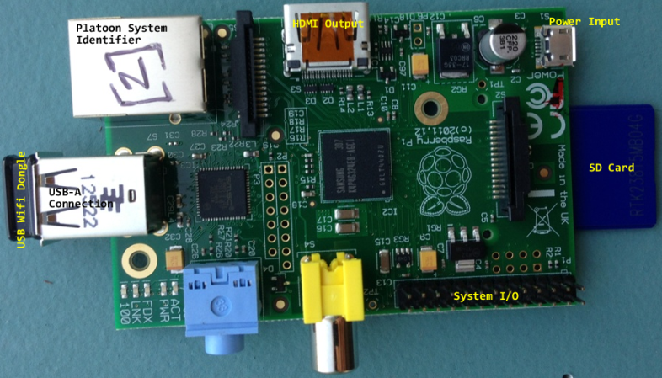

Figure – Raspberry Pi Components

* Platoon System Identifier – Values range from [1] – [6] according to the associated painting
* HDMI Output – Plug in a monitor using an HDMI cable to get screen access to Raspberry Pi
* USB Wifi Dongle – WiFi access
* SD Card – Platoon system file storage and Raspbian operating system
* System I/O – System Input/Output pins. Where the LED driver board sits
* Power Input – 5.25V, 1A Micro USB-B Input

### LED Driver Board

The LED driver board is a circuit of transistors and resistors that act as power gates for the 12V LED strips. There are two circuits, one for each LED strip, and are connected via a common system ground.

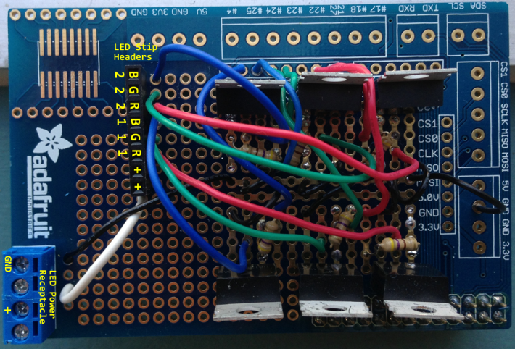

Figure - LED Driver Board Overview

* LED Power receptacle – Power and common ground from the Arduino
* LED Strip Headers – Connections for LED strips
  + Rx, Gx, Bx, - Red, Green, Blue, pinouts for strip x (1|2 since 2 strips).
  + + - 12V to LED strip

### Arduino and Protoshield

The Arduino and its attached circuit board (Protoshield) provides the following system functionality:

1. Range Sensing – Detects a user’s distance from the sensor and sends data via (USB) serial connection to Raspberry Pi
2. 12V/5V power Routing – Power the LED driver board, LCD screen, and range sensor
3. LCD Control - Display painting names

Below is an overview of the Arduino and the Arduino circuit board:

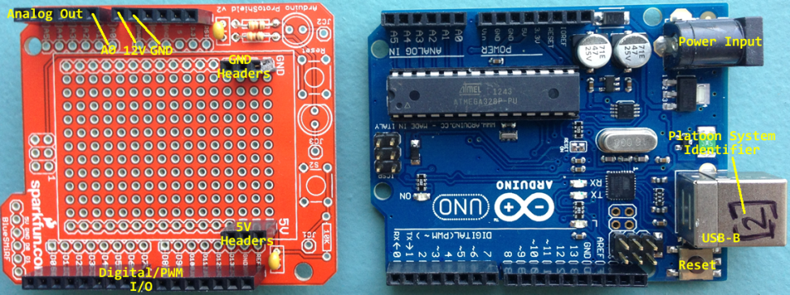

Figure - Arduino and Circuit Board

* Analog Out – Analog output pins. A0 is used for range sensor data
* 12V/GND – Supplies 12V output and common ground to LED driver board
* Digital/PWM I/O – Digital and Pulse Width Modulation (PWM) I/O pins. Provides data to LCD display.
* 5V/GND Headers – Provides power and common ground to the range sensor and LCD display
* Power Input – 12V 2A power supply connector
* Platoon System Identifier - Values range from [1] – [6] according to the associated painting
* USB–B – USB serial communications with Raspberry Pi
* Reset – Restart the Arduino

### Range Sensor

The range sensor is used to determine a user’s distance from the painting. It can use either Analog or Digital (PWM) to report distances. Below is a diagram of pertinent connections:

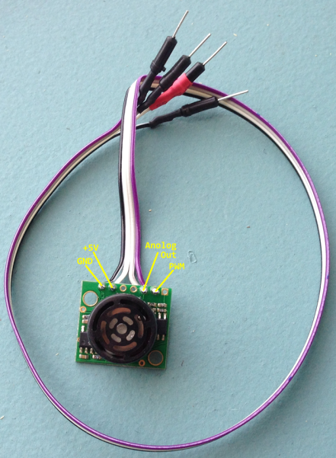

Figure - Range Sensor

### LCD Screen

The Arduino takes the hardcoded value of the painting name that is embedded in the pltnmataX.ino (X is a paintings associated system identifier) code and outputs it to the LCD screen. The LCD and its pertinent connections are shown below

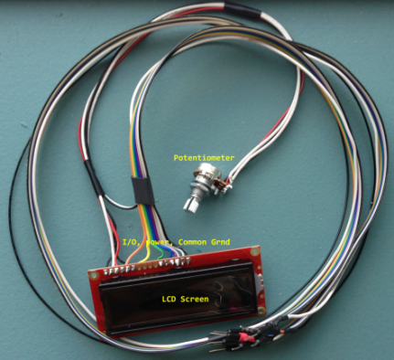

Figure - LCD Screen

* Potentiometer – 10K variable resistor controls the LCD brightness
* LCD Screen – Painting name output
* I/O, Power, Common GND – Input/Output, 5V power, and common system ground connections (detailed schematic provided in “Connecting LCD to Arduino” section)

# System Assembly

## Platoon Hardware Assembly

1. Attach LED driver board to the system I/O pins on the Raspberry PI

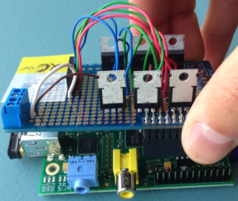

Figure - LED Driver Board Attachment to RPi

1. Connect the black (GND) and white (+12V) power wires to the LED power receptacle on the LED driver board; make sure to connect the side opposite the male pin to the receptacle. Loosen the screws on the top of the receptacle, insert the wires, and then tighten screws down until they are securely fastened.

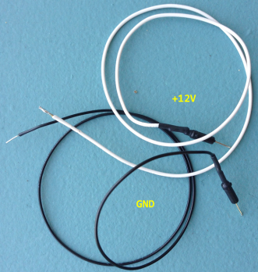

Figure - Power/GND Wires

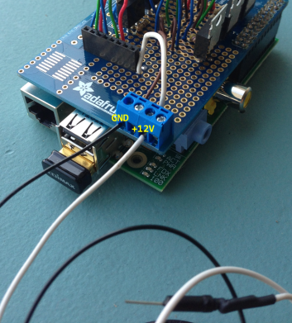

Figure - Power Wire Receptacle Placement from RPi to Arduino

1. Connect the male header end of the GND/12V wires to the 12V (called RAW on Protoshield) and GND female headers on the Arduino Protoshield as shown below:

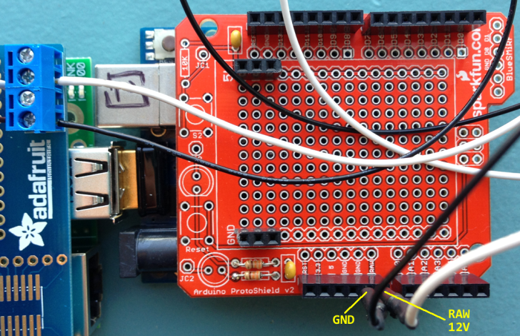

Figure - LED Driver Board Power Wires from Raspberry Pi to Arduino

1. Connect the USB-A/USB-B cable from the Raspberry Pi to the Arduino as shown below:

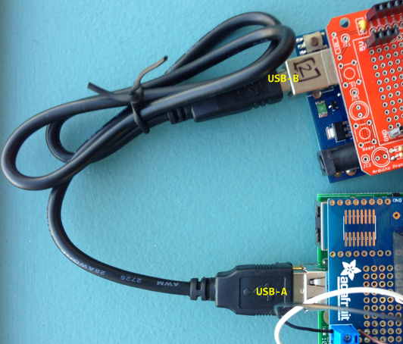

Figure - USB (serial) Connection between Arduino and Raspberry Pi

1. Connect the LCD to Arduino Protoshield per the schematic below

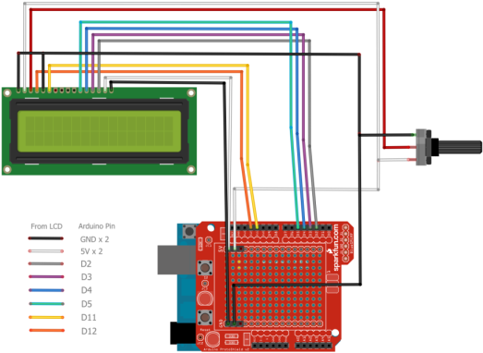

Figure - LCD --> Arduino Connections

1. Connect the range sensor per the diagram below. Note that the purple wire (PWM) is not used in the current configuration. Make sure you securely fasten the header away from any connections on the Protoshield as it may short the connection and affect the reliability of the readings

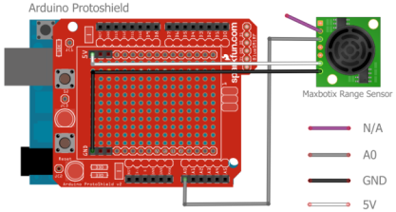

Figure - Range Sensor Connection to Arduino Protoshield

1. Connect the LED strips to the LED driver board per the schematic below

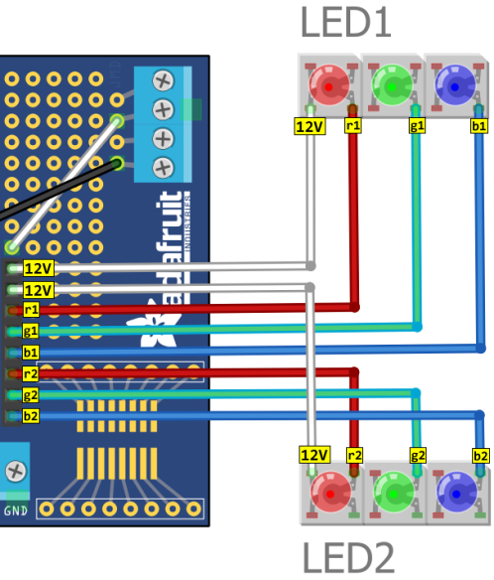

Figure - LED Strip Connection to LED Driver Board

1. Connect the 12V power Supply to the Arduino. The power light on the Arduino (visible through the Protoplate) will be lit red. The LCD screen backlight becomes visible immediately. After 5 – 10 seconds the LCD screen should display the painting name. If it doesn’t adjust the potentiometer all the way to the left until boxes are illuminated in each of the 32 character positions on the display. Slowly adjust the potentiometer to the right until the painting name is visible. If you go too far the right the letters will disappear.

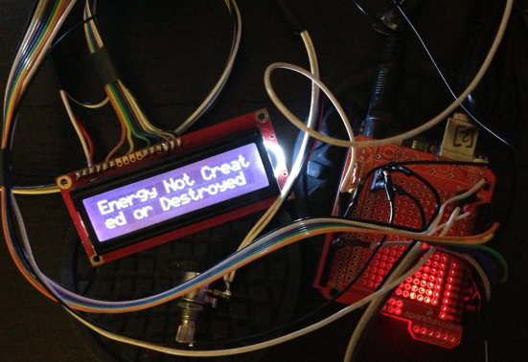

Figure - 12V Power Supply to Arduino

1. Connect the 5.25V 1A power supply to the Raspberry Pi. You will see the RPi red power LED lit up and the WiFi USB dongle flashing blue.

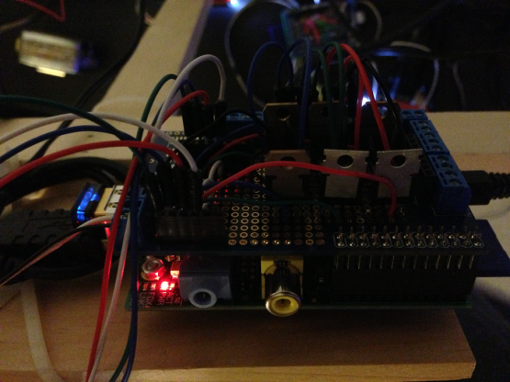

Figure - RPi Power Plugged in

Note that the Raspberry Pi will take about 1 – 2 minutes to completely boot up and start the range sensor service. Once it is started, the LEDs will rotate through the fading colors when an object enters the range between 20 and 100 inches. It will flash schizo red when an object comes within 20 inches of it.

# Software

## Development Environment

The following languages, Protocols and Software tools are used throughout the Platoon software system:

* Operating Systems
  + Raspbian Wheezy
  + Arduino firmware 0022
* Languages
  + Arduino – Range Sensor and LCD
  + Python – Software PWM, pyFirmata (Range sensor readings)
  + PERL – OSC Server
  + PHP – Web Applications
* Protocols
  + Open Sound Control (OSC)
  + Serial (pyFirmata)
  + HTTP
  + SSH
  + TCP/UDP
* Tools
  + Fritzing – Circuit design
  + TouchOSC Editor – Build OSC User Interfaces

## Architecture Overview

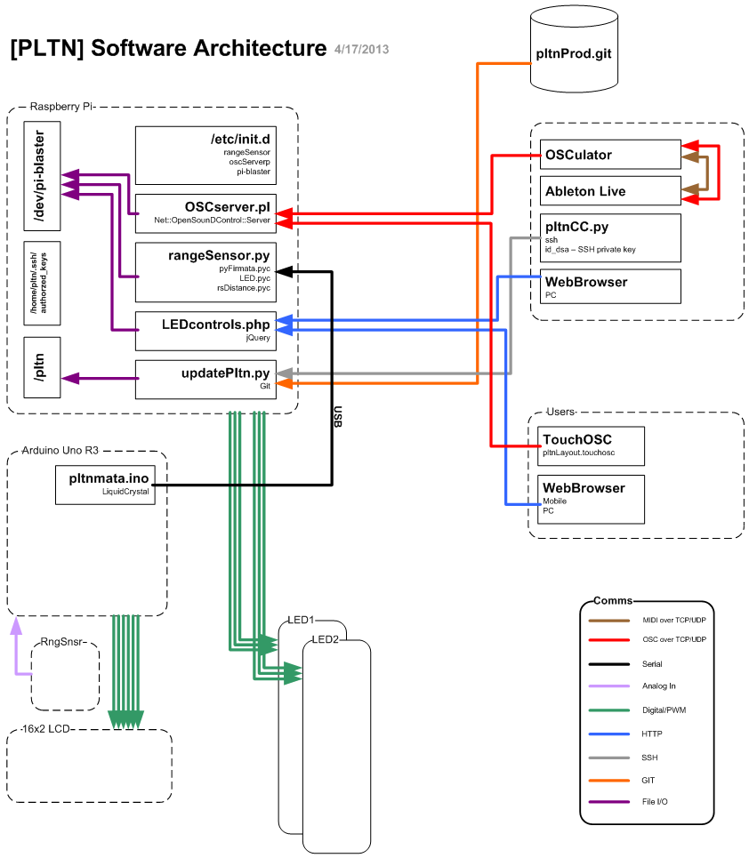

Figure - Platoon Software Architecture

## Maintenance

# User Guide

## Software Upgrades

The current version of the pltn software resides in a Git repository called pltn.git. To check out the latest version use http://

### pltnUpdate.py

1. List available versions
2. List installed versions
3. Uninstall version X
4. Install version Y

## System Maintenance

## Remote Connections

* SSH Access